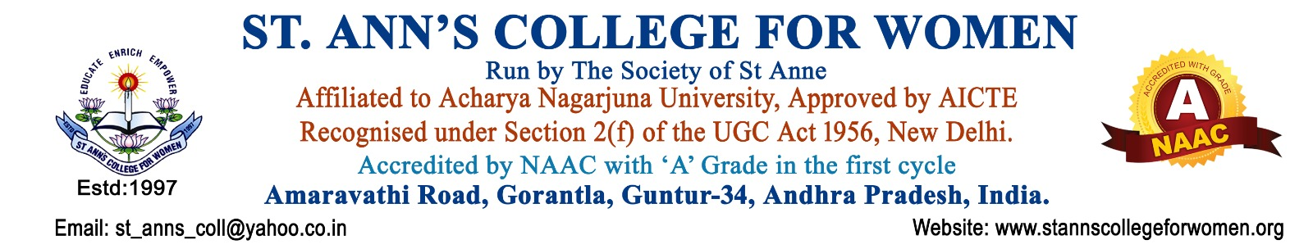

College Publications & Promotions Committee
Guidelines & Procedures
Introduction
The College Publications & Promotions Committee of St. Ann’s College for Women is constituted to strengthen institutional communication, public relations, branding, documentation, and outreach activities of the college. The committee is responsible for planning, designing, publishing, and promoting academic, co-curricular, extension, and institutional achievements through print, digital, and media platforms in accordance with UGC and NAAC quality standards.
Objectives
- To promote the vision, mission, achievements, and activities of the college effectively.
- To ensure timely publication of institutional reports, newsletters, magazines, brochures, and publicity materials.
- To maintain and regularly update the college website and social media platforms.
- To enhance the visibility and reputation of the institution through media and digital outreach.
- To document academic, cultural, extension, sports, research, and student activities systematically.
- To ensure professional communication and branding of the institution.
- To support NAAC, UGC, APSCHE, and affiliating university documentation requirements.
Composition of the Committee
The committee shall consist of:
- Chairperson – Principal
- Coordinator / Convener
- Faculty Members
- Website & Social Media Coordinators
- Photography / Documentation In-charge
- Student Representatives
- Technical Support Staff (if required)
Roles & Responsibilities
The Committee Shall:
Publications
- Plan and execute all publication activities of the college.
- Prepare and publish:
  - College Magazine
  - Newsletters
  - Annual Reports
  - Academic Reports
  - Event Reports
  - Brochures and Prospectus
- Collect articles, reports, photographs, and achievements from departments and committees.
- Ensure accuracy, quality, and timely release of all publications.
Website Management
- Maintain and regularly update the college website.
- Upload:
  - Notices and Circulars
  - Events and Activities
  - Achievements and Awards
  - Academic Information
  - NAAC & IQAC Documentation
  - Admissions and Examination Updates
- Ensure website information is authentic, updated, and user-friendly.
Promotions & Publicity
- Design posters, banners, brochures, invitations, certificates, and publicity materials.
- Publicize academic, co-curricular, extension, and extracurricular activities.
- Promote institutional achievements through digital and print media.
- Coordinate publicity for seminars, workshops, conferences, cultural events, and outreach programs.
Social Media Management
- Handle official social media platforms responsibly.
- Post regular updates regarding:
  - Student achievements
  - Faculty achievements
  - Institutional events
  - Important announcements
  - National and international observances
- Maintain professionalism and institutional ethics in digital communication.
Media Coordination
- Coordinate media coverage for important college events and achievements.
- Prepare press notes and news reports for newspapers and digital media.
- Maintain good relations with media representatives and local press.
Documentation & Archiving
- Maintain digital and physical records of:
  - Publications
  - Event Posters
  - Press Clippings
  - Photographs
  - Videos
  - Newsletters
  - Annual Reports
- Preserve documentation for NAAC and institutional records.
Operational Procedures
Planning Procedure
- Prepare an annual activity and publication plan at the beginning of the academic year.
- Schedule timelines for newsletters, magazines, reports, and publicity activities.
- Assign responsibilities to committee members.
Content Collection Procedure
- Departments and committees shall submit event reports, photographs, and achievements in prescribed format.
- The committee shall verify and edit content before publication.
Approval Procedure
- All official publications and publicity materials shall be approved by the Principal before release.
- Sensitive or official institutional information shall not be published without authorization.
Website Update Procedure
- Regular updates shall be made to the website.
- Outdated information shall be removed or archived periodically.
- Website backup and security measures shall be maintained.
Social Media Procedure
- Only authorized committee members shall manage official accounts.
- Posts shall maintain institutional dignity and professionalism.
- Inappropriate, misleading, or unauthorized content shall not be uploaded.
Event Publicity Procedure
- Posters and promotional materials shall be prepared well in advance.
- Publicity materials shall include:
  - Event title
  - Date & venue
  - Organizing department
  - Institutional branding/logo
Media Coverage Procedure
- Major institutional events shall be communicated to newspapers and media agencies.
- Press reports shall be prepared in formal format with proper photographs.
Code of Conduct
Committee members shall:
- Maintain confidentiality of official information.
- Ensure accuracy and authenticity of published content.
- Avoid misuse of institutional social media platforms.
- Respect copyright and ethical publication practices.
- Promote positive institutional image and values.
Records to be Maintained
The committee shall maintain:
- Committee Meeting Minutes
- Annual Action Plan
- College Magazine Copies
- Newsletters
- Annual Reports
- Website Update Records
- Social Media Activity Records
- Event Posters & Brochures
- Press Clippings
- Photographs and Videos
- Media Coverage Reports
- Student Handbooks
- Prospectus & Pamphlets
Expected Outcomes
- Effective institutional branding and visibility.
- Improved communication with stakeholders.
- Systematic documentation of institutional activities.
- Enhanced public image and outreach of the college.
- Strengthened NAAC quality documentation and evidence management.
Review & Monitoring
- The committee shall conduct periodic review meetings.
- Activities and publications shall be reviewed by the Principal and IQAC.
- Feedback shall be collected for continuous improvement.
Conclusion
The College Publications & Promotions Committee plays a vital role in strengthening institutional communication, documentation, visibility, and public relations. The committee contributes significantly towards promoting the achievements, academic excellence, and values of St. Ann’s College for Women while ensuring transparency, professionalism, and quality enhancement in all publication and promotional activities.

